**REVISED LESSON NOTES**

**FOR P.1**

**GRAMMAR, COMP & COMPRE**

**TERM III**

|  |  |  |  |  |
| --- | --- | --- | --- | --- |
| **Date** | **Class** | **Subject** | **No. of pupils** | **Time** |
|  |  | **Grammar** |  |  |

**Theme: Our transport**

**Subtheme: Types and means of transport**

**Competence: Read the words**

**Content: Plurals**

**Give the plurals of the words**

**one many one many**

boat – boats train – trains

bicycle – bicycles car – cars

motorcycle – motorcycles ship – ships

camel – camels aeroplane – aeroplanes

horse – horses ferry - ferries

lorry - lorries rocket - rockets

van - vans donkey - donkey

**Exercise**

**Write the plural of the word in brackets to complete the sentences**

1. The men are rowing the ___. (boat)
2. We bought new ___yesterday. (bicycle)
3. I saw ___at the airport. (aeroplane)
4. __are parked there daily. (motorcycle)
5. My father has two ___. (car)

**Construct good sentences using the given words below**

1. bicycle
2. lorries
3. aeroplane

**Underline the nouns in these sentences**

1. That knife is very sharp
2. Bring all the sticks now
3. Our teacher is smarty

**Choose the correct word from**

1. My ____ loves me so much. ( further, father)
2. Sarah ______ porridge everyday. (eats, drinks)
3. That will is _____ (laugh, rough)

|  |  |  |  |  |
| --- | --- | --- | --- | --- |
| **Date** | **Class** | **Subject** | **No. of pupils** | **Time** |
|  |  | **Grammar** |  |  |

**Theme: Things we make**

**Subtheme: Things we make at home and school**

**Competences: Read the words**

**Give the plurals of the words.**

**Content: Nouns that end with “f” or “fe” change ‘”f” to “v” and you add “es”**

**one many**

calf – calves

leaf – leaves

wolf – wolves

thief – thieves

loaf – loaves

shelf – shelves

knife – knives

wife – wives

**Except**

chief – chiefs

handkerchief – handkerchiefs

**Exercise**

**Write the singulars forms of the following words**

1. lives – 7. stories
2. knives – 8. babies
3. wires – 9. chimneys
4. leaves – 10. churches
5. calves – 11. days
6. chiefs -

**Write good sentences using these words**

leaf ______________________________________________

loaf______________________________________________

knife_____________________________________________

thief_____________________________________________

3. **Make good sentences using the given words**

knives

leaves

thieves

**Get small words from the big words**

Shelf

Handkerchief

Man

Men

Son

**Give the opposites of the underlined words**

My father is  **rich**

All **enemies**  follow Satan.

Dickson is **shorter than Jackson**

|  |  |  |  |  |
| --- | --- | --- | --- | --- |
| **Date** | **Class** | **Subject** | **No. of pupils** | **Time** |
|  |  | **Grammar** |  |  |

**Theme: Things we make**

**Subtheme: Things we make at home and school**

**Competences: Read the words**

**Give the plurals of the words.**

**Content: Plurals by changing vowels in the middle**

**Some nouns form the plural by changing to ‘e’**

**one many**

man - men

woman - women

foot - feet

tooth - teeth

goose - geese

**Noun that remain the same in singular (one) and plural (many)**

**one many**

sheep – sheep

furniture – furniture

luggage – luggage

water – water

money – money

firewood – firewood

**Exercise**

**Write the plurals**

1. sheep –
2. woman –
3. furniture
4. foot –
5. sugar –

**Give one word for the underlined group of words**

1. Mr. Busuulwa make  **chairs, doors, tables, windows and desks**
2. She likes eating **oranges, apples, mangoes and pineapples.**
3. My uncle is  **apreson who makes furniture.**
4. Miss Kityo is **a person who treats patients.**
5. Derrick  **teaches pupils at school.**

|  |  |  |  |  |
| --- | --- | --- | --- | --- |
| **Date** | **Class** | **Subject** | **No. of pupils** | **Time** |
|  |  | **Grammar** |  |  |

**Theme: Our Transport**

**Subtheme: Means of transport**

**Competence Read the words correctly.**

**Change the words into past participal tense.**

**Content: Pronouns**

A pronoun is a word used instead of a noun.

He is used for (male) boy and man

She is used for ( female) woman and girl

**Other nouns**

We, they, it

**Anita** is a girl.

She is a girl.

**Deo** is a boy.

He is a boy.

**Exercise**

**Write the correct pronoun in the brackets for the underlined word**

1. The **cat** has taken milk __________
2. **Children**  have done the exercise very well ____________
3. **Sarah and I**  are eating food.
4. **Sophia**  is my friend

**Complete correctly**

1. The _______ is shining ( son, sun)
2. All children are in class _______( running, learning)
3. We ______ food everyday. (eat, it)
4. She _______ matooke and fish(like)
5. One by one makes a __________

|  |  |  |  |  |
| --- | --- | --- | --- | --- |
| **Date** | **Class** | **Subject** | **No. of pupils** | **Time** |
|  |  | **Grammar** |  |  |

**Theme: Our transport**

**Subtheme: Means of transport**

**Competences: Read the given words correctly**

**Change words to everyday tense correctly**

**Content: Verbs**

***These are verbs where we add s /es /ies in the singular form.***

We add **“s”** to the verbs in singular

|  |  |
| --- | --- |
| **Verb** | **Everyday tense ( present simple)** |
| go  come  read  cook  write  eat  wash  cry  carry  sit  give  stand  talk  work  look  sell  buy | goes  comes  reads  cooks  writes  eats  washes  cries  carries  sits  gives  stands  talks  works  looks  sells  buys |

**Sentences**

She **goes** to school everyday. (go)

They **eat** food every Monday. (eat)

It **cries** everyday. (cry)

Mother **cooks** food everyday.(cook)

**Exercise**

**Write the given words in everyday tense**

1. Sit __________
2. Talk __________
3. Write __________
4. Come ___________
5. Read ____________

**Use the words in the brackets to complete the given sentences correctly**

1. She ______________ her bag everyday.( carry)
2. My brother ____________ his uniform every Tuesday. (wash)
3. **Complete the sentences correctly**
4. Mother is _______ food ( cook)
5. She is _______ a jerry can of water. (carry)
6. Job ________ all the food yesterday. (eat)
7. Jack ______ to school with his friends yesterday.

|  |  |  |  |  |
| --- | --- | --- | --- | --- |
| **Date** | **Class** | **Subject** | **No. of pupils** | **Time** |
|  |  | **Grammar** |  |  |

**Theme: Our transport**

**Subtheme: Means of transport**

**Competences Read the given words correctly.**

**Change the given verbs to past tense**

**Content:**

**Examples**

|  |  |
| --- | --- |
| **Verb** | **Yesterday tense ( past tense)** |
| do  go  come  eat  write  read  wash  cook  clean  talk  sleep  look  give  buy  sell | did  went  came  ate  wrote  read  washed  cooked  cleaned  talked  slept  looked  gave  bought  sold |

**Sentences**

1. Kato **went** to the village yesterday. (go)
2. Our teacher **gave** home work on Friday. (give)
3. We **ate** rice on Sunday.(eat)
4. My mother **cleaned** the house properly.(clean)
5. I **washed** my uniform on Saturday. (wash)

**Exercise**

**Change these words to yesterday tense.**

1. look_________
2. sleep _________
3. write _________
4. come_________
5. cook_________
6. buy_________

**Complete correctly.**

1. I ___________ to church on Sunday.(go)
2. We _________ to the teacher on the phone. (talk)
3. She _________ the basket alone.(carry)
4. John _________ the work neatly.(write)

|  |  |  |  |  |
| --- | --- | --- | --- | --- |
| **Date** | **Class** | **Subject** | **No. of pupils** | **Time** |
|  |  | **Grammar** |  |  |

**Theme: Things we make**

**Subtheme: Materials we use and their source**

**Competences: Read the words correctly**

**Content: Identify adjectives in sentences**

Adjectives are words that describe a noun.

**Examples of adjectives**

Size : small big thin short fat tall long

Colour: Red shoe dark skin blue dress green skirt white shirt

Others: soft smooth rough hard clean dirty

**Sentences (example)**

1. I saw a **small** car
2. This is a **red** bus
3. That wall is **rough**
4. She has **long** hair
5. I have a **blue** dress
6. Mummy is **fat**.

**Exercise**

**Underline the adjective in the sentences.**

1. That is a big tree
2. We saw a long train on a railway line
3. Nancy is a thin girl
4. My friend has a dirty uniform
5. We have a tall tree at home.

**Write the opposite of the following words**

dirty _________________________

soft___________________________

smooth________________________

fat_____________________________

tall_____________________________

**match correctly**

poor aunt

long big

rough rich

small short

uncle smooth

**Make sentences using the given words**

1. train
2. home
3. uniform
4. friend
5. dirty

|  |  |  |  |  |
| --- | --- | --- | --- | --- |
| **Date** | **Class** | **Subject** | **No. of pupils** | **Time** |
|  |  | **Grammar** |  |  |

**Theme: Things we make**

**Subtheme: Materials we use and their source**

**Competences: Read the words correctly**

**Content: Comparison of adjectives by adding only “er” or “est”**

When the word ends with a consonant but before the consonant. There a vowel letter it doubles the last letter.

**Examples of Adjectives**

Small thin fat tiny big blue short long black

Adjectives with only one word form their comparative and superlative by adding ‘er’ or ‘est’ respectively

|  |  |  |
| --- | --- | --- |
| **positive** | **comparative** | **superlative** |
| tall  short  light  clean  long  small  smart  quick  slow  weak  strong  young  old  sweet  fast | taller  shorter  lighter  cleaner  longer  smaller  smarter  quicker  slower  weaker  stronger  younger  older  sweeter  faster | tallest  shortest  lightest  cleanest  longest  smallest  smartest  quickest  slowest  weakest  strongest  youngest  oldest  sweetest  fastest |

**Exercise**

**Complete the table**

tall ______ tallest

_____ poorer ______

_____ cheaper cheapest

Short _____ shortest

**Fill in the words correctly**

1. Michael is the ________________boy among them. (tall)
2. She runs __________________than all the girls. (fast)
3. This food tastes ___________________than yours.(sweet)
4. She is a __________________girl. (smart)
5. David was __________________than Goliath.(strong)

|  |  |  |  |  |
| --- | --- | --- | --- | --- |
| **Date** | **Class** | **Subject** | **No. of pupils** | **Time** |
|  |  | **Grammar** |  |  |

**Theme: Things we make**

**Subtheme: Importance of things we make**

**Competence: Read the word correctly**

**Form the correct adjectives**

**Content: By doubling the last letter and add “er” or “est”**

Adjectives with ‘v’ we double the last letter and add ‘er’ or ‘est’ for comparative and superlative respectively.

|  |  |  |
| --- | --- | --- |
| **positive** | **comparative** | **superlative** |
| Thin  Hot  Wet  Big  Fat | Thinner  Hotter  Wetter  Bigger  Fatter | Thinnest  Hottest  Wettest  Biggest  Fattest |

**Complete the table**

thin ________ thinnest

hot hotter _____

____ longer longest

tall _______ tallest

**Fill in the words correctly**

1. Sarah is the ______________________girl among them all. (tall)
2. I am __________________________than you. (tall)
3. Give me the _____________________mango.(big)
4. The tea is too____________________________(hot)
5. The conductor was__________________than the driver.(strong)
6. This is the ____________________class in our school.(clean)

|  |  |  |  |  |
| --- | --- | --- | --- | --- |
| **Date** | **Class** | **Subject** | **No. of pupils** | **Time** |
|  |  | **Grammar** |  |  |

**Theme: Our Environment**

**Subtheme: Components and importance of things in our environment**

**Competences: Forming the correct adjectives.**

**Content: By changing “y” to “i” and add “er” or “est”**

|  |  |  |
| --- | --- | --- |
| **positive** | **comparative** | **superlative** |
| heavy  dirty  happy  hungry  easy  busy | heavier  dirtier  happier  hungrier  easier  busier | heaviest  dirtiest  happiest  hungriest  easiest  busiest |

**Exercise**

**Compete the table**

lucky ____ luckiest

dry drier ___

fat ___ fattest

___ thinner thinnest

small smaller ______

**Use the correct form of the word in bracket to complete the sentences.**

1. This boy is the _______________________in our class.(shabby)
2. The ________________girl in our class bought a new ruler.(ugly)
3. This exercise is _______________than that of yesterday.(easy)
4. The porridge is ________________than the milk.(hot)

|  |  |  |  |  |
| --- | --- | --- | --- | --- |
| **Date** | **Class** | **Subject** | **No. of pupils** | **Time** |
|  |  | **Grammar** |  |  |

**Theme: Our Environment**

**Subtheme: Factors that damage our environment.**

**Competences: Use the words in sentences.**

**Content:**

Adjective with two syllables, we just add ‘r’ or ‘st’ for comparative and superlative respective

|  |  |  |
| --- | --- | --- |
| **positive** | **comparative** | **superlative** |
| Wide  Brave  Large  Simple  Safe  White | Wider  Braver  Larger  Simpler  Safer  Whiter | Widest  Bravest  Largest  Simplest  Safest  Whitest |

**Exercise**

**Complete the table**

tall _____ tallest

hot hotter ______

_____ larger largest

safe _____ safest

short shorter _____

**Complete the sentences using the correct form of the word in brackets.**

1. It is ____________________to travel by an aeroplane than a motorcycle. (safe)
2. Our house compound is ____________________than yours.(big)
3. The river was _________________than the stream. (wide)
4. My nephew is ______________________than my niece. (tall)

|  |  |  |  |  |
| --- | --- | --- | --- | --- |
| **Date** | **Class** | **Subject** | **No. of pupils** | **Time** |
|  |  | **Grammar** |  |  |

**Theme: Our Environment**

**Subtheme: Ways of conserving the environment**

**Competences: Give the opposites of the words**

**Content: Opposites of adjectives**

**word opposite word opposite**

tall – short fat – thin

big – small heavy - light

weak – strong clean – dirty

smart – shabby long – short

quick – slow old – new / young

far – near beautiful/ handsome – ugly

wide – narrow happy – sad / unhappy

sweet – sour / bitter Shorter - longer

**Exercise**

**Write the opposites**

1. Big -
2. Happy -
3. Beautiful -
4. Long –
5. Smart –
6. Tall –
7. Clean –
8. Fat –
9. Near –

**Write the opposite of the underlined words**

1. Our teacher is a smart lady.
2. The river was very wide.
3. The mutton was very sweet.
4. Sarah has long hair.
5. The bouquet was very heavy.

|  |  |  |  |  |
| --- | --- | --- | --- | --- |
| **Date** | **Class** | **Subject** | **No. of pupils** | **Time** |
|  |  | **Grammar** |  |  |

**Theme: Our Environment**

**Subtheme: Factors that damage our environment**

**Competences: Reads the words and spells them correctly**

* **Gives the correct opposites according to the given word**

**Content: Gender of people**

**word opposite**

female male

sister brother

mother father

girl boy

niece nephew

woman man

aunt uncle

princess prince

daughter son

queen king

madam sir

lady gentleman

bride bride groom

waitress waitor

Exercise

**Give their opposites**

**Son**

**Man**

**Girl**

**Grand mother**

**House boy**

**Write a small word from a big word**

Gentle man

Waitress

Man

Mother son

|  |  |  |  |  |
| --- | --- | --- | --- | --- |
| **Date** | **Class** | **Subject** | **No. of pupils** | **Time** |
|  |  | **Grammar** |  |  |

**Theme: Our Environment**

**Subtheme: Factors that damage our environment**

**Competences: Reads the words and spells them correctly**

* **Identifies the opposites correctly**

**Content: Gender of animals**

**Feminine masculine**

Cow bull

Lioness lion

Tiger tiger

Bitch dog

Ewe ram (sheep)

Vixen fox

Sow boar/ pig

**Exercise**

1. Match correctly

**Cow dog**

**Ewe boar**

**Sow bull**

|  |  |  |  |  |
| --- | --- | --- | --- | --- |
| **Date** | **Class** | **Subject** | **No. of pupils** | **Time** |
|  |  | **Grammar** |  |  |

**Theme: Our Environment**

**Subtheme: Components and importance of things in our environment**

**Competences: Reads the words and spells them correctly**

* **Identifies the opposites correctly**

**Content: animals and their young ones**

**Animal young ones**

man baby

cow calf

monkey baby

elephant calf

pig piglet

dog puppy

sheep lamb

goat kid

lion cub

rabbit bunny

fish fry

**Exercise**

1. Give their young ones

Man _________ dog ____________

Cow _________ goat ___________

Monkey ________ pig ____________

1. Match correctly

man baby

cow calf

monkey baby

elephant calf

pig piglet

dog puppy

sheep lamb

goat kid

lion cub

rabbit bunny

fish fry

|  |  |  |  |  |
| --- | --- | --- | --- | --- |
| **Date** | **Class** | **Subject** | **No. of pupils** | **Time** |
|  |  | **Grammar** |  |  |

**Theme: Our Environment**

**Subtheme: Importance of things in our environment**

**Competences: Reads the words and spells them correctly**

* **Identifies the animals and their homes**

**Content: Animal homes**

**Animal homes**

pig sty

cow byre/ kraal

goat shed

sheep pen/ fold

rabbit hutch

man house

monkey tree

fish pond/ water

snake hole/ bush

bee bee hive

ant ant hill

**Exercise**

1. **Match correctly**

pig sty

cow byre/ kraal

goat shed

sheep pen/ fold

rabbit hutch

man house

monkey tree

fish pond/ water

snake hole/ bush

bee bee hive

ant ant hill

1. Fill in correctly

pig ________

______ hutch

goat _________

______ house

______- byre

|  |  |  |  |  |
| --- | --- | --- | --- | --- |
| **Date** | **Class** | **Subject** | **No. of pupils** | **Time** |
|  |  | **Grammar** |  |  |

**Theme: Our Environment**

**Subtheme: Importance of things in our environment**

**Competences: Reads the words and spells them correctly**

* **Oral and written questions correctly**

**Content: Animal sounds**

**Animal sound**

Cow moos

cat mews / purrs

sheep bleats

goat bleats

dog barks

pig grunts

lion roars

turkey gobbles

grass hopper chips

monkey chatters

horse neighs

hyena laughs

frog croaks

hen clucks

goose quacks

elephant trumpets

snake hisses

**Exercise**

1. Give the animal sounds

man _______

cock _______

snake_______

cow _______

cat _______

dog_______

lion_______

sheep_______

monkey_______

|  |  |  |  |  |
| --- | --- | --- | --- | --- |
| **Date** | **Class** | **Subject** | **No. of pupils** | **Time** |
|  |  | **Grammar** |  |  |

**Theme: Our Environment**

**Subtheme: Importance of things in our environment**

**Competences: Reads the words and spells them correctly**

* **Writes words and sentences correctly**
* **Identifies different animals and their meat.**

**Content: Animal meat**

**Animal meat**

Cow beef

Hen chicken

Fish fillet

Sheep mutton

Calf veal

Goat goats meat ( Cheron)

Pig pork/ bacon

Turkey turkey

**Exercise**

1. **Make sentences using the given words below**
2. fish
3. cow
4. chicken
5. sheep
6. beef
7. animal
8. **Read and draw**

hen cow pig turkey sheep fish

|  |  |  |  |  |
| --- | --- | --- | --- | --- |
| **Date** | **Class** | **Subject** | **No. of pupils** | **Time** |
|  |  | **Grammar** |  |  |

**Theme: Peace and security**

**Subtheme: Peace and security in our homes.**

**Competences: Read the sentences**

**Join the sentences using ‘than’**

**Content: Using ………….than ……….**

Than is used to compare two things

**Examples**

1. Anna is tall. Alex is taller
2. Alex is taller than Anna.
3. A taxi is big. A bus is bigger
4. A bus is bigger than a taxi

**Exercise**

**Join sentence using …than…….**

1. A bicycle is fast. A motorcycle is faster
2. A car is heavy. A lorry is heavier
3. A ship is slow. A boat is slower
4. A trailer is long. A train is longer
5. A bus is fast. An aeroplane is faster.

**Complete the sentences**

1. John is _______________________than Peter. (fat)
2. Alice is _______________________than Hebert. (young)

|  |  |  |  |  |
| --- | --- | --- | --- | --- |
| **Date** | **Class** | **Subject** | **No. of pupils** | **Time** |
|  |  | **Grammar** |  |  |

**Theme: Peace and security**

**Subtheme: Causes of insecurity**

**Competences: *Read the sentences***

***- Arranges the sentences to form a good story.***

**Content: *Jumbled composition***

1. *He was arrested.*
2. *Edgar is a thief*
3. *The shopkeeper saw him and mad an alarm.*
4. *One day he entered a shop.*
5. *He stole a packet of biscuits*

***A good story***

1. **___________________________________________**
2. **___________________________________________**
3. **____________________________________________**
4. **_____________________________________________**
5. **____________________________________________**

|  |  |  |  |  |
| --- | --- | --- | --- | --- |
| **Date** | **Class** | **Subject** | **No. of pupils** | **Time** |
|  |  | **Grammar** |  |  |

**Theme: Peace and security**

**Subtheme: Causes of insecurity**

**Competences: *Writes a composition***

**Content: *Free composition***

***Write a story about things we make***

|  |  |  |  |  |
| --- | --- | --- | --- | --- |
| **Date** | **Class** | **Subject** | **No. of pupils** | **Time** |
|  |  | **Grammar** |  |  |

**Theme: Peace and security**

**Subtheme: Causes of insecurity**

**Competences: *identifies when to use do/ does***

**Content: *He***

***The dog***

*She* ***does***

*The girl*

*It*

*Jane I work*

*We* ***do*** *every*

*We You day*

*They They*

*You* ***do He*** *time/ hour*

*The children She****does***

*I It* ***any***

*The dogs*

***Examples***

1. ***He does his work everyday.***
2. ***They do not have money.***
3. ***The dog does not eat grass.***
4. ***We do our work every evening.***

***Exercise***

***Write do / does in the gaps.***

1. ***I ______________ my homework neatly***
2. ***Sarah ___________ her work everyday.***
3. ***She _________ her duties every morning.***
4. ***We _________ our notes after lunch.***
5. ***It __________ not eat grass.***

***Circle the odd man out***

1. *Man woman girl snake*
2. *Three five circle swum*
3. *Dress cup plate saucer*
4. *Elephant tiger giraffe cow*
5. *Oranges ground nuts jack fruit sugar cane*

|  |  |  |  |  |
| --- | --- | --- | --- | --- |
| **Date** | **Class** | **Subject** | **No. of pupils** | **Time** |
|  |  | **Grammar** |  |  |

**Theme: Peace and security**

**Subtheme: Causes of insecurity**

**Competences: *Reads the pronouns correctly***

* ***Reads the sentences correctly***
* ***Constructs meaningful sentences***

***Was/ were- identifies when to use has / have***

*The rabbit*

*He* ***was***

*She*

*Sarah*

*Peter*

*We*

*They*

*You* ***were***

*children*

***Examples***

1. *He was not with my friend.*
2. *She was here yesterday*
3. *Sarah was the second in the race.*
4. *That day was rocked in the kennel.*
5. *They were together at the party*

***Activity***

***Write was/ were in the gaps***

1. *1 ________ doing my home work*
2. *All the children ______ playing together*
3. *The cat _______ shoot dead*
4. *We ________ dancing before the teacher came in*
5. *It _______ knocked down by the speeding vehicle*

**ENGLISH COMPOSITION TERM III 2017**

|  |  |  |  |  |
| --- | --- | --- | --- | --- |
| **Date** | **Class** | **Subject** | **No. of pupils** | **Time** |
|  |  | **Composition** |  |  |

**Theme:** Our transport

**Subtheme:** Types of transport

**Competences: -** Read the given words correctly

* Construct sentences using the given words

**Content: Vocabulary**

Road, railway, air, water, transport , animal

**Exercise**

1. Listen and write

__________________ __________________

__________________ __________________

__________________ __________________

1. **Make sentences using the given words**

road:- _____________________________________________________

railway :- _____________________________________________________

air :- _____________________________________________________

water :- _____________________________________________________

**3. Write these words correctly**

cadr___________________________

wayrail________________________

ira____________________________

|  |  |  |  |  |
| --- | --- | --- | --- | --- |
| **Date** | **Class** | **Subject** | **No. of pupils** | **Time** |
|  |  | **Composition** |  |  |

**Theme:** Our transport

**Subtheme:** Means of transport

**Competences: -** Read the given words correctly

* Spell and write the words correctly
* Fill in the missing letters in the given activity

**Content: Vocabulary**

Motorcycle, trailer, pick up, bus, car, ship,

boat, bicycle, train, horse, aeroplane,

ferry, yacht, lorry canoe

**Exercise**

1. **Listen and write**

__________________ __________________

__________________ __________________

__________________ __________________

__________________ __________________

1. **Fill in the missing letters**

b__at tr__in a__roplane

m__torcycl__ b__s l___rry

1. **Get a small word from the big word**
2. Motorcycle –
3. Trailer –
4. Pick up –
5. Train –
6. Aeroplane –

|  |  |  |  |  |
| --- | --- | --- | --- | --- |
| **Date** | **Class** | **Subject** | **No. of pupils** | **Time** |
|  |  | **Composition** |  |  |

**Theme:** Our transport

**Subtheme:** Means of transport

**Competences: -** Recognize the given pictures (**Mk pupils bk pg 109, 10)**

* Use this and that
* Answer questions according to the given structures.

**Content: Structures**

**What is this/ that?**

****This is a car



That is a boat

**Exercise**

**Read and draw**

1. This is a lorry
2. This is a train
3. That is a bicycle
4. That is an aeroplane
5. This is a boat

|  |  |  |  |  |
| --- | --- | --- | --- | --- |
| **Date** | **Class** | **Subject** | **No. of pupils** | **Time** |
|  |  | **Composition** |  |  |

**Theme:** Our transport

**Subtheme:** Means of transport

**Competences: -** Recognize the pictures

* Use these and those
* Answer the questions according to the given structures

**Content: Structures**

** What are these/ those?**

These are cars

Those are boats

**Exercise**

**Read and draw**

1. These are aeroplanes
2. Those are school vans
3. Those are ships
4. These are bicycles
5. Those are kites

|  |  |  |  |  |
| --- | --- | --- | --- | --- |
| **Date** | **Class** | **Subject** | **No. of pupils** | **Time** |
|  |  | **Composition** |  |  |

**Theme:** Our transport

**Subtheme:** Means of transport

**Competences: -** Recognize the pictures

* Use the correct words for the pictures

**Content: Guided picture composition**

Car boat driving riding

rowing sailing ship bicycle

**What is happening?**

|  |  |
| --- | --- |
| (1) | (2) |
|  |  |
| (3) | (4) |
|  |  |

|  |  |  |  |  |
| --- | --- | --- | --- | --- |
| **Date** | **Class** | **Subject** | **No. of pupils** | **Time** |
|  |  | **Composition** |  |  |

**Theme:** Our transport

**Subtheme:** Measures related to transport

**Competences: -** Read the words correctly

* Spell and write the words correctly
* Compare the given objects / people

**Content: Vocabulary**

tall short longer (than)

near far bigger (than)

heavy bus smaller (than)

lorry bicycle

**Structures**

1. Where is the school?

It is far from here

1. 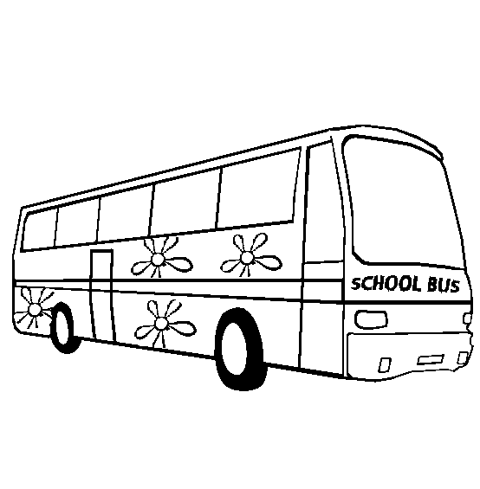Is the ___long/ short?

Yes, it is. / No it isn’t

*Which is bigger*

**

**Exercise**

1. **Complete the table**

|  |  |  |
| --- | --- | --- |
| Tall | _________ | tallest |
| near | nearer | ______ |
| _______ | longer | longest |
| heavy | ___________ | heaviest |
| small | smaller | __________ |
| ______ | shorter | shortest |
|  |  |  |

1. **Write the opposites**
2. tall ________
3. small ______
4. heavy ______
5. near ________

|  |  |  |  |  |
| --- | --- | --- | --- | --- |
| **Date** | **Class** | **Subject** | **No. of pupils** | **Time** |
|  |  | **Composition** |  |  |

**Theme:** Our transport

**Subtheme:** Means of transport

**Competences: -** Recognize the pictures

* Give the correct number of pictures accordingly.
* Write the correct number names

**Content: Pictograph**

**Using: The ……is …..than the ……………..**

**Examples**

Which is bigger?

Bus

Car

The bus is bigger than the car

1. Which is longer?



Bicycle

Train

The train is longer than the bicycle.

1. Which is smaller?



Ship

Boat

The boat is smaller than the ship.

|  |  |  |  |  |
| --- | --- | --- | --- | --- |
| **Date** | **Class** | **Subject** | **No. of pupils** | **Time** |
|  |  | **Composition** |  |  |

**Theme:** Our transport

**Subtheme:** Means of transport

**Competences: -** Write a free composition about transport “**transport”** talk about the types and means of transport

**Mk pupils bk 2 pg 61**

|  |  |  |  |  |
| --- | --- | --- | --- | --- |
| **Date** | **Class** | **Subject** | **No. of pupils** | **Time** |
|  |  | **Composition** |  |  |

**Theme:** Things we make

**Subtheme:** Things we make at home and at school

**Competences: -** Recognize the pictures given

* Give the names of the picture about things we make

**Content: Vocabulary**

mat, pot, basket, toy, ball, rope, hand bag, shaker, necklace, skirt (Their plurals should be taught)

1. **Make correct sentences**





1. **Write the plurals**
2. mat –
3. toy –
4. rope –
5. basket –
6. pot –

|  |  |  |  |  |
| --- | --- | --- | --- | --- |
| **Date** | **Class** | **Subject** | **No. of pupils** | **Time** |
|  |  | **Composition** |  |  |

**Theme:** Things we make

**Subtheme:** Things we make at home and at school

**Competences: -** Read the words correctly

* Recognize the given pictures
* Use the structure given correctly

**Content: Structures**

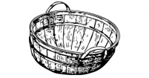 **What is that/ those?**

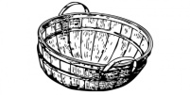 That is a basket

Those are baskets

That is a pot

Those are pots

**Exercise**

**Write the correct words**

Those are ________________________________



That is a _________________________________

Those are ________________________________



That is a _________________________________

Those are _______________________________

|  |  |  |  |  |
| --- | --- | --- | --- | --- |
| **Date** | **Class** | **Subject** | **No. of pupils** | **Time** |
|  |  | **Composition** |  |  |

**Theme:** Things we make

**Subtheme:** Materials we use and their sources

**Competences: -** Read the given words correctly.

* Tell/ mention the sources of materials used.
* Make sentences using those words given

**Content: Vocabulary**

paper, palm leaf, sisal, seeds, soil,

clay, banana fibre, stick, raffia

**Make correct sentences. What do you use to make …….?**

1. Leaf __________
2. Stick _________
3. Seeds ________

**Write the plurals**

1. Leaf _____
2. Paper ____
3. Stick _____

**Listen and write**

__________ ____________

__________ ____________

__________ ____________

**What do we make from?**

Clay ___________ palm leaves __________ seeds __________

|  |  |  |  |  |
| --- | --- | --- | --- | --- |
| **Date** | **Class** | **Subject** | **No. of pupils** | **Time** |
|  |  | **Composition** |  |  |

**Theme:** Things we make

**Subtheme:** Materials we use and their sources

**Competences: -** Recognize the pictures given

* Tell the activity which is taking place.
* Write the correct sentence on the pictures

**Content:** What is he/she doing?

|  |  |
| --- | --- |
| (1) | (2) |
| (3) | (4) |

**Exercise**

1. **What is he/ she doing?**

Picture No. 1 ______________

Picture No. 2 ______________

Picture No. 3 ______________

Picture No. 4 ______________

(making, modeling, weaving)

1. Name the four things you can see in the picture composition.
2. Name the things made from
3. Clay _____________
4. Wood ___________
5. Palm leaves ________
6. Banana fibres ________

|  |  |  |  |  |
| --- | --- | --- | --- | --- |
| **Date** | **Class** | **Subject** | **No. of pupils** | **Time** |
|  |  | **Composition** |  |  |

**Theme:** Things we make

**Subtheme:** Things we make and their uses

**Competences: -** Recognize the given pictures

* Fill the gaps with the correct words

**Content: Guided picture composition**

Peter and Jane are ________________. They make



things at _________________________

which are good. Some of them are ____________________________

_______________________ _____________



and _____________________________

(dolls, school, baskets, balls, balls, friends, ropes)

|  |  |  |  |  |
| --- | --- | --- | --- | --- |
| **Date** | **Class** | **Subject** | **No. of pupils** | **Time** |
|  |  | **Composition** |  |  |

**Theme:** Things we make

**Subtheme:** Things we make and their uses

**Competences: -** A free composition

Write a free composition about things we make at home

**“** Things we make”

|  |  |  |  |  |
| --- | --- | --- | --- | --- |
| **Date** | **Class** | **Subject** | **No. of pupils** | **Time** |
|  |  | **Composition** |  |  |

**Theme:** Our environment

**Subtheme:** Components and importance of things in our environment

**Competences: -** Read the sentence correctly

* Fill the gaps with the correct words from the baskets

**Content: Vocabulary**

Trees, birds, dog, rabbit, hen, sheep, plant, zebra, monkey

Lion, elephant, snake, flower

**Exercise**

1. **Fill in the missing letters**

B__rd m __ nkey tr __ __ l __on r___bbit

El __phant sn ___ke fl __wer

1. **Read and draw**
2. Musa is going to school.
3. Mary is climbing a tree.
4. He is rowing a boat
5. The hen has six chicks.

|  |  |  |  |  |
| --- | --- | --- | --- | --- |
| **Date** | **Class** | **Subject** | **No. of pupils** | **Time** |
|  |  | **Composition** |  |  |

**Theme:** Our environment

**Subtheme:** Components and importance of things in our environment

**Competences: -** Read the words given correctly

* Spell and write the words correctly.
* Construct meaningful sentences using those words

**Content: Structures**

**What is this / that?**

This is a tree

That is a tree

**Exercise**

**Write correct sentences on the given pictures**

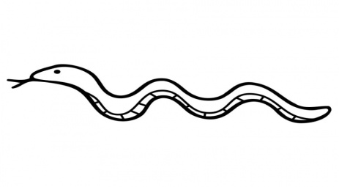





|  |  |  |  |  |
| --- | --- | --- | --- | --- |
| **Date** | **Class** | **Subject** | **No. of pupils** | **Time** |
|  |  | **Composition** |  |  |

**Theme:** Our environment

**Subtheme:** Components and importance of things in our environment

**Competences: -** Use the structures correctly

* Write the words according to the pictures

**Content: Structures**

**What are these/ those?**

These are trees.



Those are hens

**Exercise**

**Write the correct words for the given pictures**

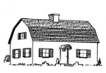These are _______________________________

These are ____________________________



Those are ___________________



Those are _________________________



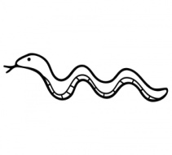Those are _____________________

|  |  |  |  |  |
| --- | --- | --- | --- | --- |
| **Date** | **Class** | **Subject** | **No. of pupils** | **Time** |
|  |  | **Composition** |  |  |

**Theme:** Our environment

**Subtheme:** Factors that damage our environment

**Competences: -** Read the words correctly

* Spell and write the words correctly
* Construct meaningful sentences using the words given

**Content: Vocabulary**

tree, cut, rain, axe, grass, fire, land, sand, ground, cow, goat, wind, leaf

**Make correct sentences**

1. Cutting
2. Raining
3. Grazing

**Complete correctly**

1. I have four legs

I give people meat, milk and hides

What am I? ______________

1. I am red in colour

I help people to cook food and get warm

What am I? _____________

1. When I fall

People get water, plants grow

What am I? ___________

1. I am strong.

When I blow clothes dry

Kites fly

What am I? ____________

|  |  |  |  |  |
| --- | --- | --- | --- | --- |
| **Date** | **Class** | **Subject** | **No. of pupils** | **Time** |
|  |  | **Composition** |  |  |

**Theme:** Our environment

**Subtheme:** Ways of conserving the environment

**Competences: -** Read the words correctly

* Answer the given questions correctly

**Content: Vocabulary**

Soil , tree, watering can, rake, hoe , slasher

**Get small word from the big word**

1. Soil –
2. Plant –
3. Watering –

**Name these pictures**

|  |  |  |  |
| --- | --- | --- | --- |
|  | C:\Documents and Settings\SECRETARY\Desktop\CORNERSTONE EXTERNAL WORK\NEWTON\Drawings\impact\Illustration art\axe-t18876.jpg | C:\Users\user\Desktop\scan0004.jpg |  |
|  |  |  |  |

What do we use ……… for?

**Match correctly**

Watering can for collecting rubbish

Slasher for digging

Hoe for slashing

Rake for watering plants

|  |  |  |  |  |
| --- | --- | --- | --- | --- |
| **Date** | **Class** | **Subject** | **No. of pupils** | **Time** |
|  |  | **Composition** |  |  |

**Theme:** Our environment

**Subtheme:**

**Competences: -** Read the given words correctly

* Spell and write the words correctly
* Construct meaningful sentences using the words given

**Content: Structures**

What is he/ she doing?

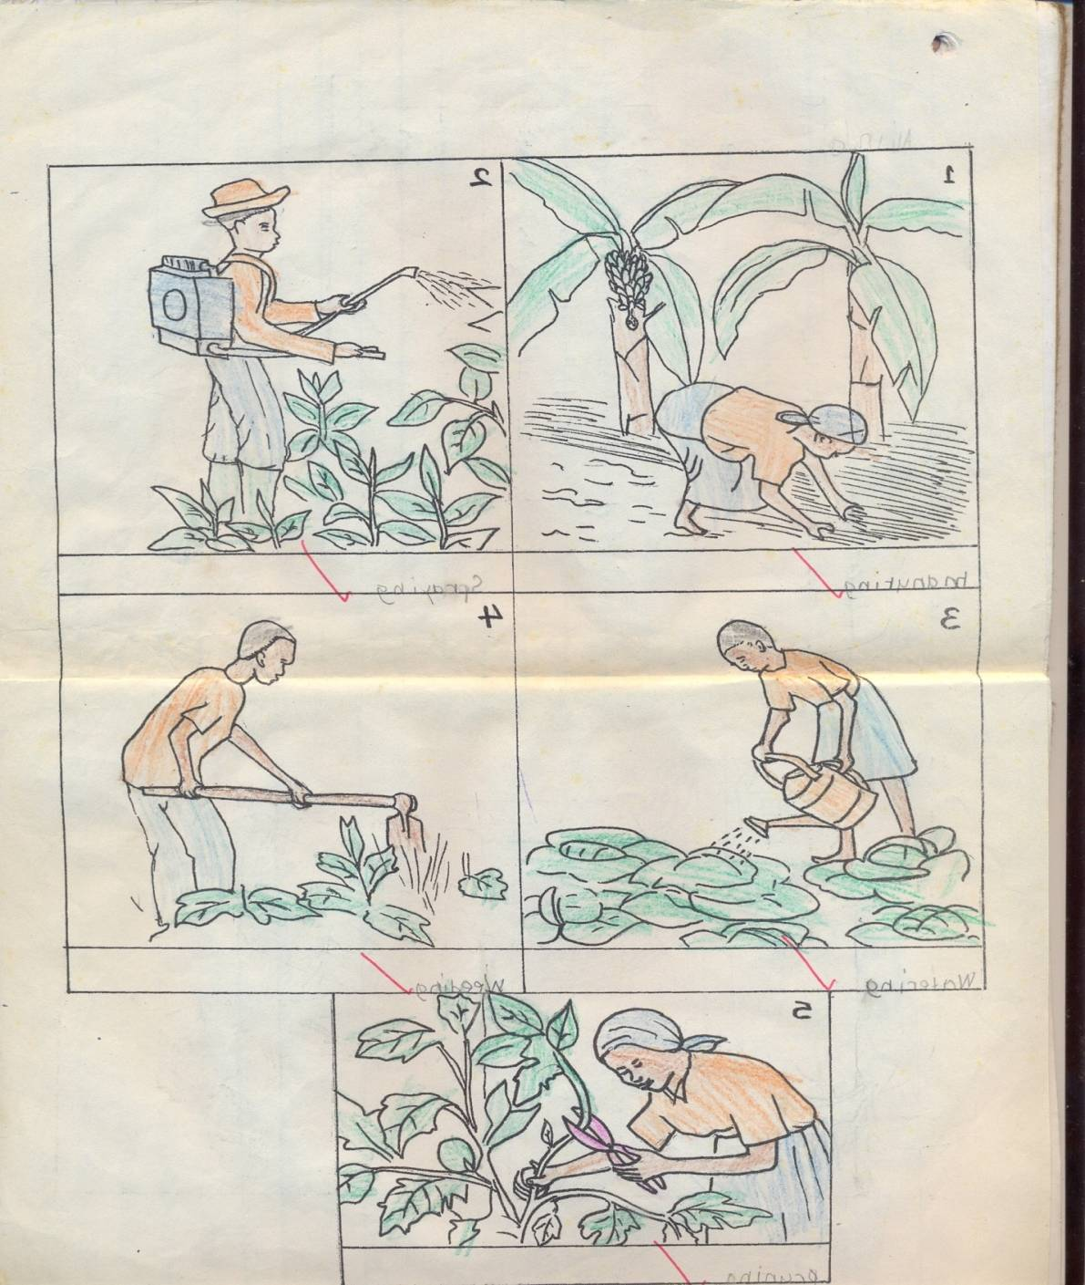

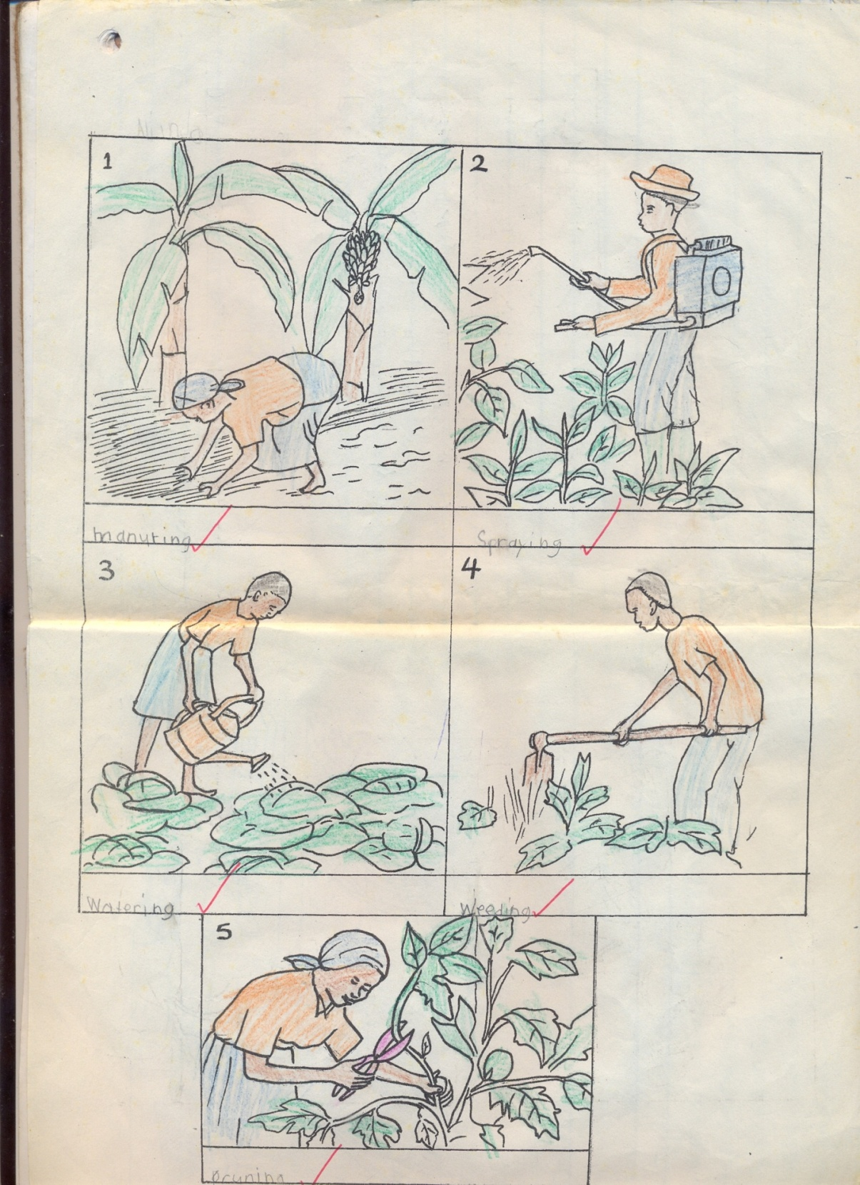

|  |  |  |  |  |
| --- | --- | --- | --- | --- |
| **Date** | **Class** | **Subject** | **No. of pupils** | **Time** |
|  |  | **Composition** |  |  |

**Theme:** Our environment

**Subtheme: ways of conserving the environment**

**A free composition**

**Write a composition about animals**

**Animals**

**Talk about domestic and wild animals**

**Competences: -** Read the given words correctly

* Spell and write the words correctly

|  |  |  |  |  |
| --- | --- | --- | --- | --- |
| **Date** | **Class** | **Subject** | **No. of pupils** | **Time** |
|  |  | **Composition** |  |  |

**Theme:** Peace and Security

**Subtheme:** Peace and security in our homes

**Competences: -** Read the given words correctly

* Spell and write the words correctly
* Answer the given questions correctly

**Content: Vocabulary**

Fire**,** fight , spear, gun, knife, needle, stick, stone, share, help, pray, play

**Use these words in sentences**

1. Pray –
2. Play –

**What are these**

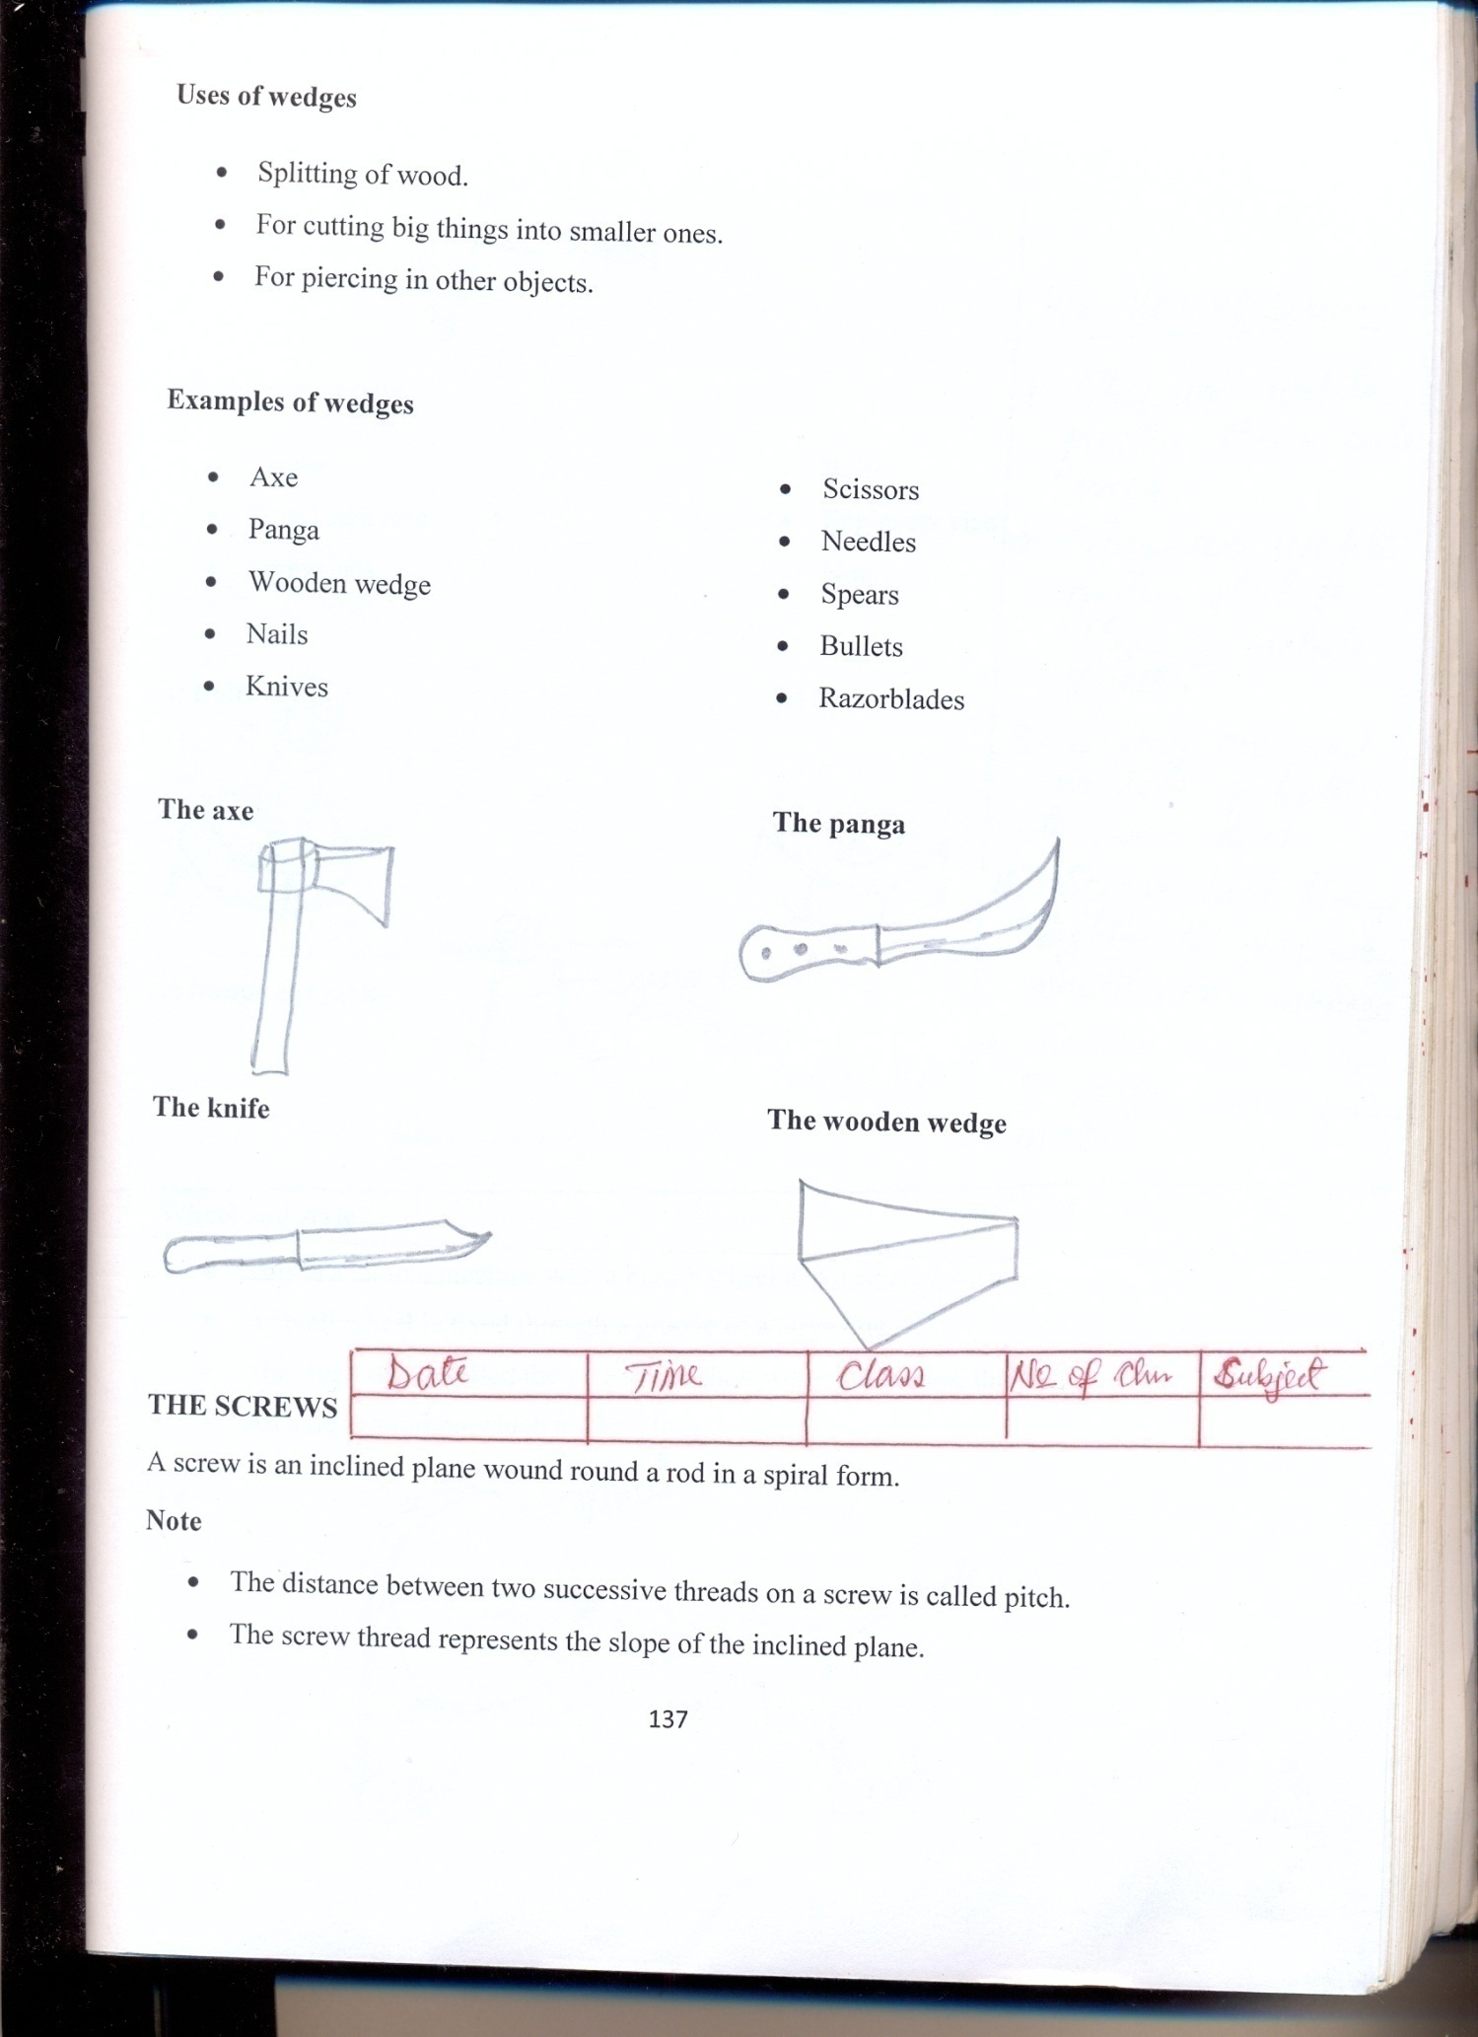





1. Read and draw

gun spear

fire stone

needle knife

|  |  |  |  |  |
| --- | --- | --- | --- | --- |
| **Date** | **Class** | **Subject** | **No. of pupils** | **Time** |
|  |  | **Composition** |  |  |

**Theme:** Peace and Security

**Subtheme:** Causes of insecurity

**Competences: -** Recognize the pictures for the structures

* Use the structures correctly.
* Answer the questions correctly

**Content: Structure**

**Who has _________(gun)?**

A policeman has a **gun**.

A priest has a **bible**.

**Exercise**

1. Who has a bible?

____________________

1. Who has a syringe?

____________________

1. Who has a knife?   
   ____________________
2. Who has a spear**?**

____________________

1. **Write correctly**

mesticdo

idwi

irdsb

sectsin

malsani

peolep

**JUMBLED COMPOSITION**

|  |  |  |  |  |
| --- | --- | --- | --- | --- |
| **Date** | **Class** | **Subject** | **No. of pupils** | **Time** |
|  |  | **Composition** |  |  |

**Theme:** Peace and Security

**Subtheme:** Causes of insecurity

**Competences: -** Reads,spells, arranges the story to make a correct composition.

**Content : Jumbled composition**

1. *He stole a car and a television.*
2. *The policeman chased him.*
3. *One day a thief came to our house.*
4. *The man was a policeman.*
5. *There lived a man.*

|  |  |  |  |  |
| --- | --- | --- | --- | --- |
| **Date** | **Class** | **Subject** | **No. of pupils** | **Time** |
|  |  | **Composition** |  |  |

**Theme:** Peace and Security

**Subtheme:** Promoting peace at home

**Competences: -** Read the given words correctly

* Spell and write the words correctly.
* Use those words in sentences

**Content: Vocabulary**

Share, help, pray, friends, play

**Make good sentences**

1. Praying –
2. Playing –
3. Sharing –
4. Structure

**What are they doing?**

1.  They are ________to God. (pray)
2. They are _________football. (play)



1. They are ______ (fight)
2. Good children are __________mangoes. (share)
3. ___________one another is the best practice. (help)

|  |  |  |  |  |
| --- | --- | --- | --- | --- |
| **Date** | **Class** | **Subject** | **No. of pupils** | **Time** |
|  |  | **Composition** |  |  |

**Theme:** Peace and Security

**Subtheme:** People who keep peace and security in our community

**Competences: -** Read the structures given

* Recognize the pictures for the structures.
* Answer the questions correctly

**Content: Vocabulary**

Policeman, policewoman, elder, religious leader, child, man, woman, boy, girl

**Write the opposites**

1. man _____
2. boy ______
3. policeman _____

**Give the plurals**

1. child _____
2. man ____
3. boy ___
4. policeman ___

**Content: Structures**

**What does he/ she do?**

**Examples**

Teacher – teachers learners

Nurse – cares for the sick

**Exercise**

**Match correctly**

Policeman treats patients

Religious leader keeps law and order

Doctor preaches the word of God.

Barber mends shoes

Cobbler shaves hair

|  |  |  |  |  |
| --- | --- | --- | --- | --- |
| **Date** | **Class** | **Subject** | **No. of pupils** | **Time** |
|  |  | **Composition** |  |  |

Picture composition

|  |  |
| --- | --- |
| W:\2016 DOCUMENTS\drawings\all drawings others\teacher.PNG | W:\2016 DOCUMENTS\drawings\all drawings others\police man.PNG |
|  | C:\Users\user\Desktop\SCANS\scan0003.jpg |

Make sentences

1. _______________________
2. _______________________
3. _______________________
4. _______________________

Jumbled composition

**Arranging sentences to form a correct story**

1. He was arrested
2. Edgar is a thief
3. The shopkeeper saw him and made an alarm
4. One day, he entered a shop
5. He stole a packet of biscuits

**A good story**

|  |  |  |  |  |
| --- | --- | --- | --- | --- |
| **Date** | **Class** | **Subject** | **No. of pupils** | **Time** |
|  |  | **Composition** |  |  |

**Theme:** Peace and Security

**Subtheme:** Promoting peace and security at home

**Competences: -** A free composition writing

* Write a composition about people who keep peace and security in the community

**People who keep peace and security**

**ENGLISH COMPREHENSION TERM III 2017**

|  |  |  |  |  |
| --- | --- | --- | --- | --- |
| **Date** | **Class** | **Subject** | **No. of pupils** | **Time** |
|  |  | **Comprehension** |  |  |

**Theme:** Our transport

**Subtheme:** Means of transport

**Competences: -** Reading the dialogue correctly

* Identifying new words
* Pronouncing the words correctly.
* Answering the given questions correctly.

**Content: The true friends**

**Tom**: Good morning, John. Our friend Musa didn’t come to school today.

**John**: Why? What happened?

**Tom**: He fell off his bicycle

**John**: Oh , how did it happen?

**Tom**: He was riding down the hill when the bicycle got a flat tyre.

**John**: You mean a flat tyre can cause an accident?

**Tom**: Oh yes. Especially if you are riding at a high speed.

**Questions**

1. What is the title of the dialogue?
2. Who were the true friends?
3. *How many people are talking in the dialogue?*
4. *Who fell off his bicycle*
5. *Draw Musa falling off his bicycle*

|  |  |  |  |  |
| --- | --- | --- | --- | --- |
| **Date** | **Class** | **Subject** | **No. of pupils** | **Time** |
|  |  | **Comprehension** |  |  |

**Theme:** Our transport

**Subtheme:** Means of transport

**Competences: -** Identifying and reading new words

* Pronouncing the words correctly
* Answering the given questions correctly

**Content: The passage**

**Were’s bicycle**

**Were goes to Cornerstone Junior School. She lives at Kitete which is near** Mukono town. Her uncle bought her a bicycle. She uses a bicycle as a means of transport to and from school. One day, Were’s bicycle had a flat tyre. She took the bicycle to the mechanic There was a puncture. He repaired it for were and she rode it again.

**Questions**

1. Write the title of the story.
2. Where does were live?
3. Which means of transport does Were use to go to school?
4. Draw Were riding a bicycle.
5. What is the story about?

|  |  |  |  |  |
| --- | --- | --- | --- | --- |
| **Date** | **Class** | **Subject** | **No. of pupils** | **Time** |
|  |  | **Comprehension** |  |  |

**Theme:** Our transport

**Subtheme:** Means of transport

**Competences: -** Studies the pictograph

* Answer the questions correctly

**Content: Pictograph**

**Study the pictograph and answer the questions about it.**

|  |  |
| --- | --- |
| **Name of children** | **Items** |
| ***Jane*** |  |
| ***Calvin*** |  |
| ***Mary*** |  |
| ***Peter*** |  |

**Questions**

1. ***Who has bicycles?***
2. ***How many children are in the pictograph?***
3. ***Who has an earoplane?***
4. ***How many cars has Calvin?***
5. ***____________ has two ships***

|  |  |  |  |  |
| --- | --- | --- | --- | --- |
| **Date** | **Class** | **Subject** | **No. of pupils** | **Time** |
|  |  | **Comprehension** |  |  |

**Theme:** Our transport

**Subtheme:** means of transport

**Content: Read the story below and answer the questions about it.**

**Sandra goes to school**

Sandra is a pupil in Primary one. Studies from Kololo primary school. She goes to school by a school van. The school van picks her from home at 7:00am and takes her back home at 4:30pm.

One day while in class, teacher taught them about means of road transport. These were cars, buses, lorries, bicycles and many others. The lesson was very interesting. Sandra loves her school.

**Questions**

1. Where does Sandra study from?
2. What means does she use to go to school?
3. In which class is Sandrah
4. Who drives the school van?
5. How do you come to school?
6. Draw these means of transport

|  |  |  |  |
| --- | --- | --- | --- |
|  |  |  |  |
| car | lorry | bicycle | donkey |

|  |  |  |  |  |
| --- | --- | --- | --- | --- |
| **Date** | **Class** | **Subject** | **No. of pupils** | **Time** |
|  |  | **Comprehension** |  |  |

**Theme:** Our transport

**Subtheme:** Measures related to transport

**Content: Read the story below and answer the questions about it.**

**Visiting friends**

We visit friends on Saturdays. We go to their houses and play with the children.

Our mothers respect each other. They talk and share the tea together.

We share Fanta and oranges. We love to eat together with our friends and share every little thing we get and then go back home.

**Questions**

1. What is the tittle of the story?
2. Who respects each other?
3. What do children share?
4. On which day do children visit their friends?
5. Make sentences using the words below.
6. houses
7. children
8. mother
9. share

|  |  |  |  |  |
| --- | --- | --- | --- | --- |
| **Date** | **Class** | **Subject** | **No. of pupils** | **Time** |
|  |  | **Comprehension** |  |  |

**Theme:** Things we make

**Subtheme:** Things we make at school

**Competences: -** Identifying the things we make at school

* Answering questions about the table

**Content: A Table. Things pupils make at school**

|  |  |  |  |
| --- | --- | --- | --- |
| **Name** | **Balls** | **Mats** | **Baskets** |
| Tendo | 5 | 3 | 8 |
| Mukasa | 4 | 2 | 7 |
| Birungi | 5 | 4 | 2 |
| Phillip | 6 | 3 | 4 |

**Questions**

1. What is the table about? The table is about ……………………..
2. How many balls did Jane make? Jane made …………………….balls
3. How many balls were made altogether _________balls were made altogether.
4. Draw four balls and three baskets.

|  |  |  |  |  |
| --- | --- | --- | --- | --- |
| **Date** | **Class** | **Subject** | **No. of pupils** | **Time** |
|  |  | **Comprehension** |  |  |

**Theme:** Things we make

**Subtheme:** Things we make at school

**Competences: -** Reading the dialogue correctly

* Identifying new words
* Pronouncing the words answering the questions correctly.

**Content: A dialogue**

**Things we make at school**

**Teacher**: Good evening children.

**Pupils**: Good evening teacher

**Teacher**: Everyone should bring banana fibres, sisal and straws tomorrow

**Pule**: What are these things for teacher?

**Teacher**: They are for making ropes and balls

**Pupils**: Yeeeeeeeeesssssssss

**Teacher**: Everybody will make a rope and a ball.

**Sharon**: Teacher, I will make a big ball and a long rope.

**Nakato**: Shall we use them to play?

**Teacher**: Yes, ropes for skipping and balls for kicking.

**Pupils**: Thank you madam Betty.

**Questions**

1. Mention the people talking in the dialogues?
2. What is the dialogue about?
3. **Match things we make and their materials**

ropes clay

mats banana fibres

pots polythene papers

bags palm leaves

baskets raffia

|  |  |  |  |  |
| --- | --- | --- | --- | --- |
| **Date** | **Class** | **Subject** | **No. of pupils** | **Time** |
|  |  | **Comprehension** |  |  |

**Theme:** Our environment

**Subtheme:** Components of environment

**Competences: -** Identifying new words

* Pronouncing and reading the words correctly
* Answering the given questions correctly.

**Content: A story**

**Mary a craft girl**

Mary is a hardworking girl. She stays with her grandmother, she makes many things. These are basket, brooms, doormats, winnowers and mats. She sells these crafts and gets school fees for her self. Mary is in primary one. She is a bright girl.

**Questions**

1. Write the title of the story.
2. What is the story about?
3. What is the title of the story?
4. Mention the things Mary makes.

Read and draw

|  |  |  |
| --- | --- | --- |
| Basket | Brooms | Mats |
|  |  |  |

|  |  |  |  |  |
| --- | --- | --- | --- | --- |
| **Date** | **Class** | **Subject** | **No. of pupils** | **Time** |
|  |  | **Comprehension** |  |  |

**Theme:** Our Environment

**Subtheme:** Components of environment

**Competences: -** Read the given passage correctly

* Identifying new words
* Pronounce the words in the passage correctly

**Content: A peaceful village**

One day, in the village of Masaka. People cut trees for timber, charcoal, firewood and poles for buildings. People looked for firewood and there was no more. The wind came and blew off people’s houses and plantation. After some time the village was in peace after planting trees again.

**Questions**

1. What is the name of the village?
2. Name three things people get from trees.
3. What blew off people’s houses?
4. Write the title of the passage.

|  |  |  |  |  |
| --- | --- | --- | --- | --- |
| **Date** | **Class** | **Subject** | **No. of pupils** | **Time** |
|  |  | **Comprehension** |  |  |

**Theme:** Our environment

**Subtheme:** Importance of things in our environment

**Competences: -** Read the tongue twister

* Pronouncing the words correctly
* Answering the given questions correctly.

**Content: A tongue twister**

A sailor went to the sea. To see what he could see. But all what he could see was the sea shells at the bottom of the deep blue sea.

**Questions**

1. Who went to the sea?
2. List five words with “s” sound
3. What is the name of the sea?
4. What did the sailor see at the bottom of the sea.

|  |  |  |  |  |
| --- | --- | --- | --- | --- |
| **Date** | **Class** | **Subject** | **No. of pupils** | **Time** |
|  |  | **Comprehension** |  |  |

**Theme:** Our environment

**Subtheme:** Components and importance of things in our environment

**Competences: -** Reading the dialogue correctly

* Identifying new words
* Read the given passage correctly
* Pronounce and spell the words correctly

**Content: The passage**

**Seasons in Uganda**

There are two main seasons in Uganda. The wet and the dry season. There is a lot of rain during the wet season. Farmers plant crops and weed them. A heavy storm destroys crops. This is not good for farmers.

During the dry season, there are very many interesting things.

**Questions**

1. What is the title of passage?
2. How many seasons are in Uganda?
3. Mention the two seasons in Uganda
4. What do farmers do to their crops?
5. Draw a man digging.

|  |  |  |  |  |
| --- | --- | --- | --- | --- |
| **Date** | **Class** | **Subject** | **No. of pupils** | **Time** |
|  |  | **Comprehension** |  |  |

**Theme:** Our environment

**Subtheme:** Components and importance of things in our environment

**Competences: -** Read the poem correctly

* Answer the questions about the poem in full sentences

**Content: Poem**

**Oh! Environment**

Environment! Environment! Environment!

What a great place to live in. with good plants, hills, buildings, animal and lakes.

They are all good to look at.

God made them with one heart.

**Questions**

1. What is the poem about?
2. List down things which are found in our environment.
3. Who made the environment with one heart?
4. Draw these

|  |  |  |  |  |
| --- | --- | --- | --- | --- |
|  |  |  |  |  |
| Hills | Lake | River | Building | Animal |

|  |  |  |  |  |
| --- | --- | --- | --- | --- |
| **Date** | **Class** | **Subject** | **No. of pupils** | **Time** |
|  |  | **Comprehension** |  |  |

**Theme:** Peace and security

**Subtheme:** Peace and security at home and at school

**Competences: -** Read the passage correctly

* Pronounce the words correctly
* Spell and write the words correctly

**Content: The passage**

**The stubborn boys**

The three boys who always fought. One day, in a little school up the hill. Three boys fought in class and broke chairs and windows. The headmaster sent them home for two weeks. So that they can learn to be good boys. He also asked their parents to repair the broken chairs and windows.

**Questions**

1. What is the title of the passage?
2. How many people are in the passage?
3. Draw two boys fighting
4. Who gave them the punishment?

|  |  |  |  |  |
| --- | --- | --- | --- | --- |
| **Date** | **Class** | **Subject** | **No. of pupils** | **Time** |
|  |  | **Comprehension** |  |  |

**Theme:** Peace and security

**Subtheme:** Peace and security at home and at school

**Competences: -** Recites the hyme

* Spells the new words
* Answers the questions about the rhyme correctly.

**Content: Child responsibilities.**

**Children Children**

Respect your parents, elders and fellow children.

Work for the unity of your home.

Respect culture and the culture of other people.

Be tolerant of traditions and join in positive culture and customary activities.

Respect the independence and unity of countries.

Work towards the development of your society and country.

**Questions**

1. What is the tittle of the rhyme?
2. Write the title of the rhyme.
3. Who should respect parents?
4. What is the rhyme about?

Children should work for the ________ of their homes.

|  |  |  |  |  |
| --- | --- | --- | --- | --- |
| **Date** | **Class** | **Subject** | **No. of pupils** | **Time** |
|  |  | **Comprehension** |  |  |

**Theme:** Peace and Security

**Subtheme:** Peace and Security at home

**Competences: -** Read the dialogue correctly

* Identify the new words
* Pronounce the words and answer the questions correctly

**Content: A dialogue**

**A thief**

**Susan**: Good morning Alice.

**Alice**: Good morning Susan

**Susan**: We slept badly last night

**Alice**: Last night! What happened?

**Susan**: A thief broke into our house.

**Alice**: What did he take?

**Susan**: He did not take anything. My brother Moses made an alarm.

**Alice**: Did the police come for help?

**Susan**: Yes, they did

**Alice**: Thank you.

**Questions**

1. Write the title of the dialogue
2. Who broke into the house?
3. Which group came fro help?
4. What is the dialogue about?
5. Draw a policeman running after the thief.

|  |  |  |  |  |
| --- | --- | --- | --- | --- |
| **Date** | **Class** | **Subject** | **No. of pupils** | **Time** |
|  |  | **Comprehension** |  |  |

**Theme:** Peace and security

**Subtheme:** Peace and security at home and at school

**Competences: -** Identifies words out of the puzzle.

**Content: Make words from the puzzle**

|  |  |  |  |  |  |  |  |  |  |  |  |  |  |  |
| --- | --- | --- | --- | --- | --- | --- | --- | --- | --- | --- | --- | --- | --- | --- |
| p | c | o | m | m | u | n | i | t | y | d | c | r | p | A |
| e | l | o | p | n | r | e | s | p | e | c | t | l | a | s |
| a | u | z | o | e | m | c | l | d | e | r | s | m | r | h |
| c | b | c | d | e | f | g | h | i | j | k | m | n | o | p |
| e | d | i | l | r | h | e | a | l | t | h | y | p | n | i |
| t | m | n | d | i | s | e | a | s | e | m | s | q | o | n |
| s | e | c | u | r | i | t | y | u | r | n | t | r | s | e |

|  |  |  |  |  |
| --- | --- | --- | --- | --- |
| **Date** | **Class** | **Subject** | **No. of pupils** | **Time** |
|  |  | **Comprehension** |  |  |

**Theme:** Peace and security

**Subtheme:** Causes of insecurity

**Competences: -** Identifies when to use do/ does

**Content:**

He We

The dog They

She does You do

The girl The children

It I

Jane The dogs

**Examples**

1. He does his work every day.
2. They do not have money.
3. The dog does not eat grass.
4. We do our work every evening

**Revision work**

|  |  |  |  |  |
| --- | --- | --- | --- | --- |
| **Date** | **Class** | **Subject** | **No. of pupils** | **Time** |
|  |  | **Grammar** |  |  |

**Theme: Peace and security**

**Subtheme: Causes of insecurity**

**Content: Prepositions**

Preposition: A word used with a noun or pronouns to show place, position, time or method.

in, - on, - near,

under, - over, - between,

behind - in front of - against

by, - on, - at, - to

**Make correct sentences using these words**

**Examples**

1. to – The girl is pointing **to** the roof
2. between – I sit **between** Jane and Paul
3. on – I go to school **on** foot

**Exercise**

**Construct the sentences using the words below.**

1. over –
2. in –
3. on –
4. behind –

**Fill in the correct word**

1. John goes to school ____________________foot.
2. The bird is flying _________________the house.
3. The waiter shared the cake ___________________the twins.
4. She is leaning _______________________the wall.
5. The teacher is standing in front __________________the class.

|  |  |  |  |  |
| --- | --- | --- | --- | --- |
| **Date** | **Class** | **Subject** | **No. of pupils** | **Time** |
|  |  | **Grammar** |  |  |

**Theme: Peace and security**

**Subtheme: Causes of insecurity in our homes**

**Competences: Making correct sentences using the pictures**

**Content: Form correct sentences using the given pictures**

















|  |  |  |  |  |
| --- | --- | --- | --- | --- |
| **Date** | **Class** | **Subject** | **No. of pupils** | **Time** |
|  |  | **Grammar** |  |  |

**Theme: Peace and security**

**Subtheme: Causes of insecurity in our homes**

**Competences: Mention the words which take article a/an**

**Fill the gaps with the correct article**

**Content: Articles**

**Article “a”**

Words which start with consonant sounds take article “a” before them. These consonants are: b, c, d, f, g, h, j, k, l, m, n , p, q, r, s, t, v, w, x, y, z,

**e.g.**

- a tree - a mat - a doll

- a bag - a hen - a mat

- a kitten - a zip

**Article “an”**

**Words which start with vowel sounds take article “an” before them.**

Vowels include: a, e, i, o, u

-an apple - an egg - an insect

-an owl - an umbrella

**Exercise**

1. _____elephant is a big animal
2. I ate _______orange last evening
3. Annet has __________ pen.
4. I have __________new dress.